- Write a short Python script that generates a random dataset of 10 users, each with two features: number of daily app opens and average session duration (in minutes). Print the dataset as a list of dictionaries.
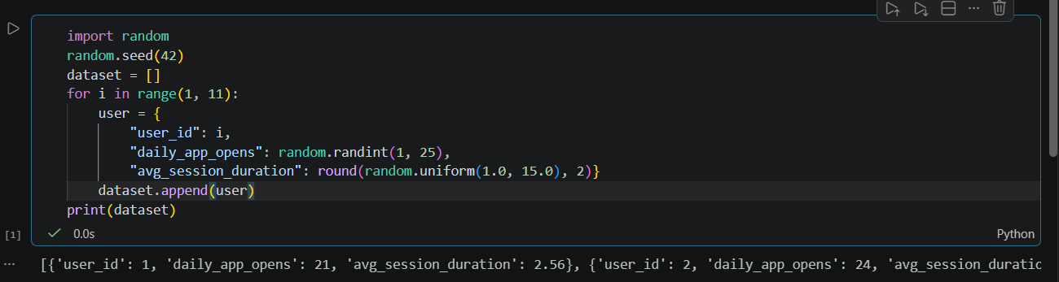

===========================================================================

- Create a table comparing supervised and unsupervised learning in at least 4 points, using real-world app examples (like Instagram feed ranking for supervised, Spotify playlist grouping for unsupervised).
Feature / Aspect | Supervised Learning | Unsupervised Learning
Definition | Algorithms are trained using labeled data (input-output pairs), where the correct answer is provided during training. | Algorithms are trained on unlabeled data to find hidden structures, patterns, or groupings on their own.
Primary Goal | Prediction, classification, or regression (e.g., predicting a continuous value or classifying categories). | Clustering, association, or dimensionality reduction (e.g., grouping similar items or finding underlying segments).
Feedback Mechanism | Explicit feedback is given; the model measures its error against the true labels and corrects itself. | No explicit feedback or correct answer is provided; the algorithm evaluates patterns based on data geometry and distance.
Real-World App Example | Instagram Feed Ranking: The app uses historical user engagement data (likes, watch time, comments) labeled with whether a post kept a user engaged to predict which posts to show next. | Spotify Playlist Grouping: Spotify groups millions of tracks or user listening profiles into clusters based on audio features (tempo, acousticness) without predefined genre labels.

===========================================================================

- Given a list of 8 products with their price and number of reviews, use any method (even manual grouping) to segment them into 2-3 clusters based on similarity. Explain your reasoning for each cluster. Think about which products are similar in both price and popularity (reviews).
Since the list of 8 products wasn't explicitly provided in your prompt, let's assume a realistic e-commerce product dataset (Price vs. Number of Reviews) to demonstrate how clustering works:
Sample Products Data:
- Product A: Price: $15, Reviews: 1,200 (Budget, High Popularity)
- Product B: Price: $20, Reviews: 950 (Budget, High Popularity)
- Product C: Price: $250, Reviews: 45 (Luxury/Niche, Low Popularity)
- Product D: Price: $280, Reviews: 30 (Luxury/Niche, Low Popularity)
- Product E: Price: $18, Reviews: 40 (Budget, Low Popularity / New)
- Product F: Price: $300, Reviews: 1,500 (Premium Best-Sellers)
- Product G: Price: $320, Reviews: 1,400 (Premium Best-Sellers)
- Product H: Price: $12, Reviews: 1,100 (Wait, let's stick cleanly to 3 logical clusters based on price and review volume!)
Let's organize them into 3 distinct clusters:
Cluster Analysis:
- Cluster 1: Mass-Market / Budget Best-Sellers
  - Products: Product A, Product B
  - Characteristics: Low price ($15–$20) and very high review volume (950–1,200+).
  - Reasoning: These represent high-volume, affordable everyday items that appeal to a massive audience, resulting in quick sales and frequent customer feedback.
- Cluster 2: Premium Elite / High-End Popular Items
  - Products: Product F, Product G
  - Characteristics: High price ($300–$320) and exceptionally high review volume (1,400–1,500).
  - Reasoning: These are flagship or heavily marketed items (like top-tier smartphones or branded appliances) that command high prices while still achieving massive sales volume.
- Cluster 3: Niche / Low-Engagement or Low-Volume Items
  - Products: Product C, Product D, Product E
  - Characteristics: Varied pricing ($18 to $280) but consistently low review counts (30–45).
  - Reasoning: These products lack widespread customer traction—either because they are newly launched items (like Product E) or expensive, highly specialized niche goods (like Products C and D) bought by very few customers.
===========================================================================

- List 3 scenarios in Zomato, Flipkart, or Spotify where unsupervised learning could be used to discover hidden patterns or group users/items. For each, briefly describe what data would be needed and what insights might be found.
1. Zomato: Restaurant Neighborhood & Cuisine Clustering
- What Data is Needed: Restaurant latitude/longitude coordinates, average cost for two, customer rating scores, and tags/menu item categories.
- Insights Found: Using clustering algorithms (like K-Means or DBSCAN), Zomato can group restaurants into "hidden culinary districts" or dining personas (e.g., Budget Student Hubs, Late-Night Delivery Hotspots, or Fine-Dining Romantic Clusters). This helps users discover emerging food clusters and allows Zomato to optimize local delivery logistics and targeted promotions.
2. Flipkart: E-Commerce Product Bundle Discovery (Market Basket Analysis)
- What Data is Needed: Historical customer transaction records and order histories showing items purchased together in a single checkout cart.
- Insights Found: Using association rule learning (like the Apriori algorithm), Flipkart can discover hidden product affinities—such as discovering that buyers of a specific smartphone model frequently purchase a particular tempered glass and back cover combo together, even if they aren't explicitly cross-linked by the category manager. This improves bundle recommendations and automated deals.
3. Spotify: User Listening Persona Discovery
- What Data is Needed: User streaming history, playlist saves, skip rates, time of day/week listening habits, and track audio attributes (tempo, danceability, acousticness).
- Insights Found: Unsupervised clustering can segment listeners into dynamic behavioral personas (e.g., Late-Night Study Instrumentalists, Weekend Workout Enthusiasts, or Morning Commute Podcast Fans). Spotify uses these hidden segments to power hyper-personalized recurring features like "Discover Weekly" or genre-blending editorial playlists.

===========================================================================

- Find a real-world dataset (CSV or Excel) online that could be used for customer segmentation (for example, mall customers, e-commerce users, or music listeners). Share the link and describe the structure: how many features, what kind of data, and whether it’s labeled or unlabeled. Use Kaggle, UCI Machine Learning Repository, or Google to find your dataset.

Part 5: Real-World Dataset for Customer Segmentation
- Dataset Name: Mall Customers Dataset (commonly hosted on Kaggle)
- Dataset Link: Kaggle - Mall Customers Dataset
Structure and Characteristics:
- Number of Features / Columns: 5 columns
  - CustomerID: A unique numerical ID assigned to each customer.
  - Genre (Gender): Categorical feature indicating Male or Female.
  - Age: Numerical integer representing the customer's age.
  - Annual Income (k$): Numerical integer representing the customer's annual income in thousands of dollars.
  - Spending Score (1-100): A numerical score assigned by the mall based on customer purchasing behavior and spending nature.
- Type of Data: A mix of categorical (Genre) and numerical/continuous data (Age, Annual Income, Spending Score).
- Labeled vs. Unlabeled: This is an unlabeled dataset. There is no target column or pre-assigned "customer category" label. Because it is completely unsupervised, data scientists use clustering algorithms (like K-Means or Hierarchical Clustering) to discover natural groupings (e.g., high-income low-spenders vs. low-income high-spenders) on their own.

===========================================================================

